## Add Sensor Calibration

### Description

This energy efficiency measure (EEM) adds sensor drift faults to airside economizer controls by adding FaultModel:TemperatureSensorOffset:OutdoorAir and FaultModel:TemperatureSensorOffset:ReturnAir objects to all Controller:OutdoorAir objects attached to air loops and having functioning airside economizers present in the model. The sensor faults are configured based on the pre-existing setting for “Economizer Control Type”. The sensor drifts are hard coded to values of +2°F for the OA Dry Bulb Sensor and -2°F for the RA Dry Bulb Sensor and +5 Btu/lb for the OA Enthalpy Calculation and -5 Btu/lb for the RA Enthalpy Calculation. The enthalpy error is equivalent to having a Relative Humidity sensor error of +/- 4% RH accuracy and Dry Bulb Temperature Sensor of +/-2°F accuracy. Sensor drift limits are hard coded to reasonable values for sensor quality based on published ASHRAE documentation.

### Modeler Description

This energy efficiency measure (EEM) is an EnergyPlus measure that loops through all Controller:OutdoorAir objects and adds sensor faults to economizer sensor nodes. As appropriate, sensor drifts for return and outside air temperature and enthalpy are added to the model, based on the “Economizer Control Type” setting. If the Economizer Control Type is set to “No Economizer”, no actions are taken. Drift limits are hard coded to reasonable values for sensor quality based on published ASHRAE documentation.

### Use Case Types

Model Articulation, Retrofit EE, New Construction EE

### Arguments

No arguments

### Initial Condition Message

The initial model contained {X} applicable OS:Controller:OutdoorAir objects for which this measure is applicable.

### Final Condition Message

{Z} OS:Controller:OutdoorAir Economizer control objects were modified to incorporate sensor drift.

### Not Applicable Messages

The model contains no Controller:OutdoorAir objects for which this measure is applicable.

### Warning Messages

None

### Information Messages

Did something to object 1. Etc.

### Error Messages

### None

### Code Outline

Loop through all AirLoops in the model having OS:Controller:OutdoorAir objects

If OS:Controller:OutdoorAir.EconomizerControlType = “No Economizer”

then write Info message of measure not applicable for the outdoor air controller on this airloop

If OS:Controller:OutdoorAir.EconomizerControlType = “Fixed Dry Bulb” or “Differential Dry Bulb”

then

1. Retrieve OS:Controller:OutdoorAir name
2. Add FaultModel:TemperatureSensorOffset:OutdoorAir idf snippet

FaultModel:TemperatureSensorOffset:OutdoorAir,

<OS:Controller:OutdoorAir {name} Return Air Sensor Bias>, !- Name

ALWAYS_ON, !- Availability Schedule Name

, !- Severity Schedule Name

Controller:OutdoorAir, !- Controller Object Type

{OS:Controller:OutdoorAir name}, !- Controller Object Name

1.11; !- Temperature Sensor Offset

1. Add FaultModel:TemperatureSensorOffset:ReturnAir idf snippet

FaultModel:TemperatureSensorOffset:ReturnAir,

<OS:Controller:OutdoorAir {name} Return Air Sensor Bias>, !- Name

ALWAYS_ON, !- Availability Schedule Name

, !- Severity Schedule Name

Controller:OutdoorAir, !- Controller Object Type

{OS:Controller:OutdoorAir name}, !- Controller Object Name

-1.11; !- Temperature Sensor Offset

If OS:Controller:OutdoorAir.EconomizerControlType = “Fixed Enthalpy” or “Differential Enthalpy” or “Electronic Enthalpy”

1. Retrieve OS:Controller:OutdoorAir name
2. Add FaultModel:EnthalpySensorOffset:OutdoorAir idf snippet

FaultModel:EnthalpySensorOffset:OutdoorAir,

<OS:Controller:OutdoorAir {name} Return Air Sensor Bias>, !- Name

ALWAYS_ON, !- Availability Schedule Name

, !- Severity Schedule Name

Controller:OutdoorAir, !- Controller Object Type

{OS:Controller:OutdoorAir name}, !- Controller Object Name

5; !- Enthalpy Sensor Offset (5kJ/kg)

1. Add FaultModel:EnthalpySensorOffset:ReturnAir idf snippet

FaultModel:EnthalpySensorOffset:ReturnAir,

<OS:Controller:OutdoorAir {name} Return Air Sensor Bias>, !- Name

ALWAYS_ON, !- Availability Schedule Name

, !- Severity Schedule Name

Controller:OutdoorAir, !- Controller Object Type

{OS:Controller:OutdoorAir name}, !- Controller Object Name

-5; !- Enthalpy Sensor Offset (5kJ/kg)

If OS:Controller:OutdoorAir.EconomizerControlType = “Fixed Dew Point and Dry Bulb” or “Differential Dry Bulb and Enthalpy”

then

1. Add these objects described in above sections
   1. FaultModel:TemperatureSensorOffset:OutdoorAir idf
   2. FaultModel:TemperatureSensorOffset:ReturnAir .idf
   3. FaultModel:EnthalpySensorOffset:OutdoorAir idf
   4. FaultModel:EnthalpySensorOffset:ReturnAir .idf

### Tests

**This measure applies to:**

1. Secondary School
2. Primary School
3. Outpatient Healthcare
4. Large Office

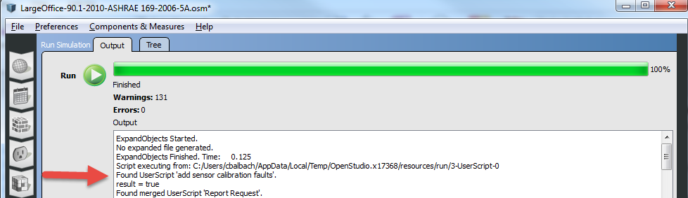

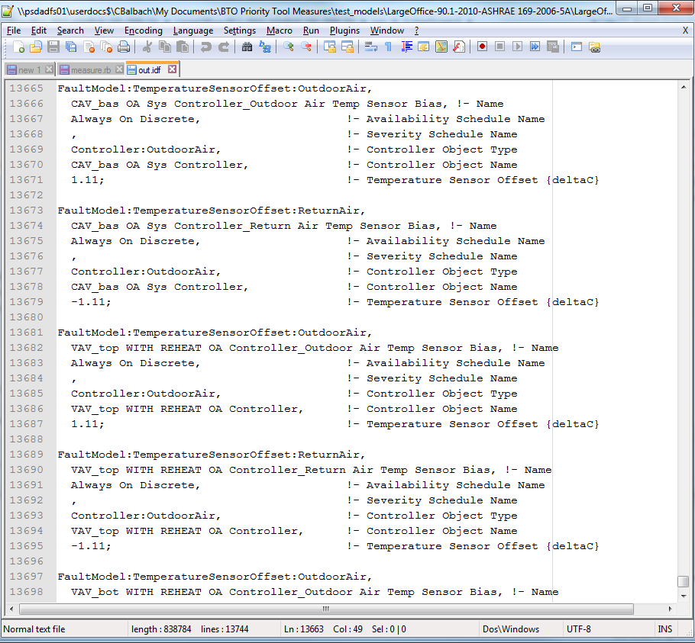

1. Hospital
2. Large Hotel

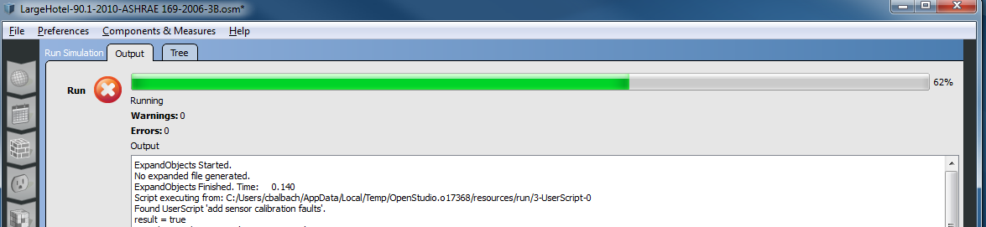

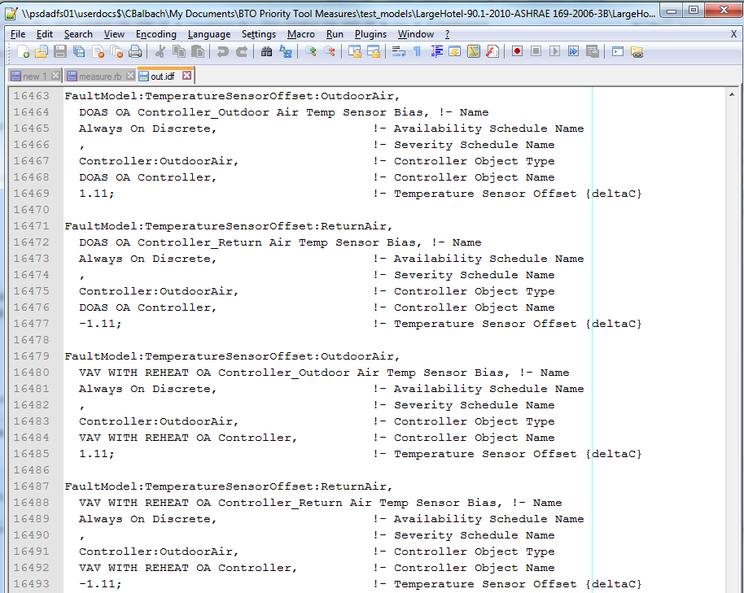

1. Warehouse
2. Midrise Apartment
3. Small Office

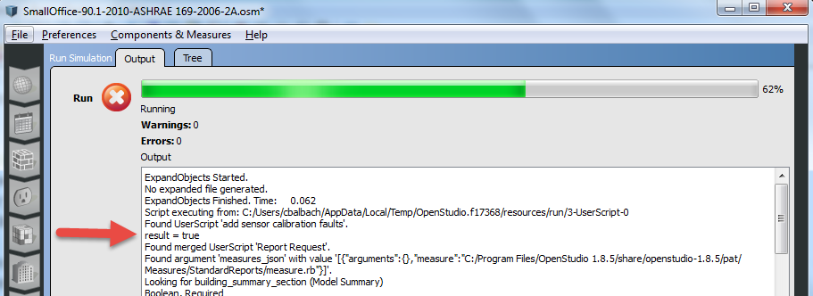

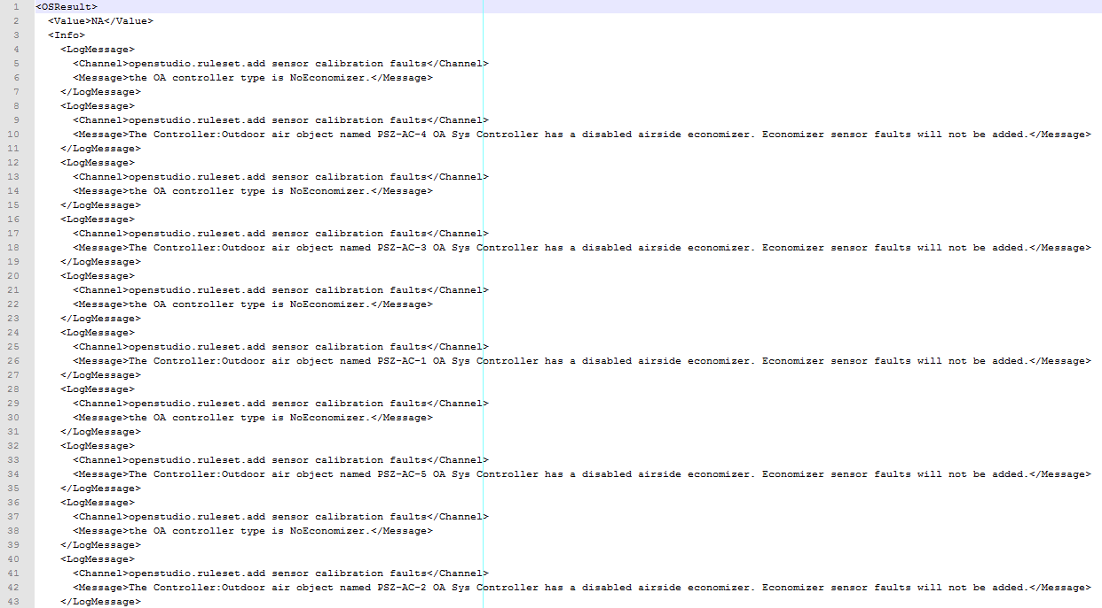

1. Medium Office
2. Stand-Alone Retail
3. Strip Mall
4. Supermarket
5. Quick Service Restaurant
6. Full Service Restaurant
7. Small Hotel

**This measure does not apply to:**

NOTE: Airside Economizers and specific controls are present in different variants of the prototype models based on both the strictness of the particular 90.1 standard and the location of the prototype model.

**Test results:**

Run the simulation using prototype .osm files, examine the results, cut and paste some before/after screenshots/evidence that makes you think that the measure is working correctly, including generating messages.

Engineering Notes

The hard coded sensor error/drift limits for dry bulb and enthalpy temperature sensors are sourced from page 9 of this recent ASHRAE Journal Article:

<http://www.taylor-engineering.com/downloads/articles/ASHRAE%20Journal%20-%20Economizer%20High%20Limit%20Devices%20and%20Why%20Enthalpy%20Economizers%20Don%27t%20Work%20-%20Taylor%20&%20Cheng.pdf>

* Values used for dry bulb drift are +2°F (+1.11°C) for the Outdoor Air Sensor and -2°F (-1.11°C) for the Return Air Sensor
* Values used for enthalpy drift are +2 Btu/lb (+5 kJ/kg) for the Outdoor Air Sensor and -2 Btu/lb (-(-5 kJ/kg) for the Return Air Sensor